CodeTerra:

Contents

User/Testing Guide: 2

Home Page: 2

Navbar: 2

Search Results Page: 3

Developer’s Perspective: 5

# User/Testing Guide:

## Home Page:

* The home page is the primary point of interaction on this website.

## Navbar:

* At the top we can see the navbar, which provides access to the most important functions for users.
* They can access the home page from anywhere, alongside the useful pages dropdown that leads to some misc. functional pages. While many pages were initially accessible from the dropdown, they are now strategically accessible from other places.
* The New Post Button brings users to the new post page or login form depending on whether they are logged in.
* The Search Button performs an Ajax Request on pages where threads are displayed and updates the content. Try typing “maybe“ into the search bar on the home page to see this in action. You can press enter to go to the search page.

**At any time on the home page, you can switch the Selection to change how threads load:**

* All to see all posts that exist on the database/site.
* Popular to see the most upvoted posts
* New to see the newest posts first.

## A screenshot of a computer Description automatically generated with medium confidenceSearch Results Page:

The search results page displays posts based on keywords identified in either the title or post content. Try typing into the search bar on this page to find other posts.

**Login Modal:**

* The Login Button allows users to sign in. If they do not have an account, they can also go to the new account page from here. When signed in, it will update to the user account name.

When logged in, the modal will display info about your account, and allow you to access the change password page. I would have loved to add more interactive info but did not find the time to do so.

# Developer’s Perspective:

## Bootstrap:

* I utilized the Bootstrap framework for most of my site design. I heavily used flexbox/flex grid for layout.
* Bootstrap nav for header.
* Bootstrap Footer (on Home Page only)

PHP

PHP is heavily used in the composition of pages. It is used to facilitate database requests, inserts, and for page composition. For instance I only have two styles of navbars, one where threads exist on the page for search to load into, and one without. I utilize php’s include feature to reduce my document length, and have easily modifiable modular page composition. This also allowed me to also ensure consistency on my pages.

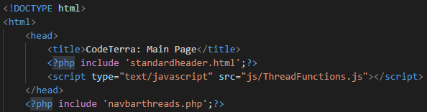

Using PHP’s include to bring the navbar into the page.

PHP files are also utilized to generate post modules for display on page.

Processfindpostpreview and processfindposthandler fetch posts based on postID, and display them on the home page, and other pages. I rely on LoadThreads.php to call the right postID’s and load the appropriate content from the former handlers.

LoadThreads calls processfindpostpreview with PostID’s determined prior based on the selection of category on homepage (“New” for instance).

JavaScript Files are used for form verification, and to trigger AJAX requests. For instance, my upvote and downvote functionality rely on an AJAX request to modify the value, and get the new vote count back for display. Upvotes and Downvotes both work, but I have not been able to limit their functionality to only being clickable once. As it currently is set up, a user may mass spam upvotes or downvotes.

Session and State variables are utilized primarily for tracking the user’s login status, and storing their username for easy access.

Due to time constraints, I was unable to implement a moderation page, comment functionality, and post/comment removal functionality into the site. If I had time to keep working on this, this would be where I would put more effort.